TABLE OF CONTENTS

1. P-N JUNCTION DIODE CHARACTERISTICS 1
2. ZENER DIODE CHARACTERISTICS 6
3. TRANSISTOR COMMON -BASE CONFIGURATION 11
4. TRANSISTOR CE CHARACTERSTICS 16
6. FULL-WAVE RECTIFIER 26
7. FET CHARACTERISTICS 31
8. h-PARAMETERS OF CE CONFIGURATION 36
9. TRANSISTOR CE AMPLIFIER 43
10. COMMON COLLECTOR AMPLIFIER 48
11. RC COUPLED AMPLIFIER 53
12. COMMON SOURCE FET AMPLIFIER 58
13. WEIN BRIDGE OSCILLATOR 63
14. RC PHASE SHIFT OSCILLATOR 66
15. CURRENT-SERIES FEEDBACK AMPLIFIER 71
16. VOLTAGE-SERTES FEEDBACK AMPLIFIER 77
17. HARTLEY OSCILLATOR 83
18. COLPITT’S OSCILLATOR 87
19. SILICON-CONTROLLED RECTIFIER(SCR) CHARACTERISTICS 91
20. UJT CHARACTERISTICS 95
21. BRIDGE RECTIFER 99
rajeev@tec:::::::created this:::::::::::::::::::::::::::::::::::::::::::::::::::::::::::::::::

1. P-N JUNCTION DIODE CHARACTERISTICS

AIM:-To observe and draw the Forward and Reverse bias V-I Characteristics of a P-N Junction diode.
APPARATUS:-

P-N Diode IN4007.
Regulated Power supply (0-30v)
Resistor 1KΩ
Ammeters (0-200 mA, 0-500mA)
Voltmeter (0-20 V)
Bread board
Connecting wires
THEORY:-
A p-n junction diode conducts only in one direction. The V-I characteristics of the diode are curve between voltage across the diode and current through the diode. When external voltage is zero, circuit is open and the potential barrier does not allow the current to flow. Therefore, the circuit current is zero. When P-type (Anode is connected to +ve terminal and n- type (cathode) is connected to –ve terminal of the supply voltage, is known as forward bias. The potential barrier is reduced when diode is in the forward biased condition. At some forward voltage, the potential barrier altogether eliminated and current starts flowing through the diode and also in the circuit. The diode is said to be in ON state. The current increases with increasing forward voltage.
When N-type (cathode) is connected to +ve terminal and P-type (Anode) is connected –ve terminal of the supply voltage is known as reverse bias and the potential barrier across the junction increases. Therefore, the junction resistance becomes very high and a very small current (reverse saturation current) flows in the circuit. The diode is said to be in OFF state. The reverse bias current due to minority charge carriers.

CIRCUIT DIAGRAM:-
FORWARD BIAS:-
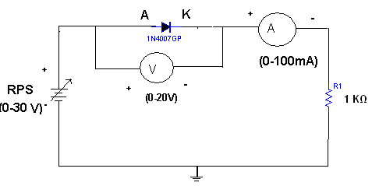
REVERSE BIAS:-

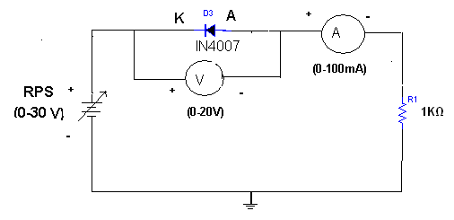

MODEL WAVEFORM:-

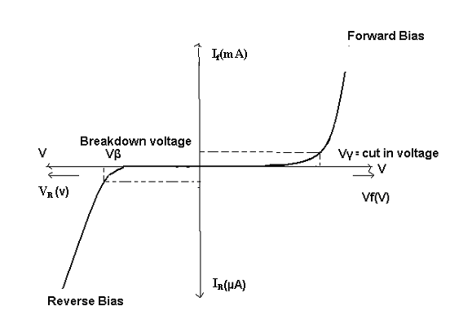
PROCEDURE:-
FORWARD BIAS:-

1. Connections are made as per the circuit diagram.
2. For forward bias, the RPS +ve is connected to the anode of the diode and
RPS –ve is connected to the cathode of the diode,
3. Switch on the power supply and increases the input voltage (supply voltage) in
Steps.
4. Note down the corresponding current flowing through the diode and voltage
across the diode for each and every step of the input voltage.
5. The reading of voltage and current are tabulated.
6. Graph is plotted between voltage and current.

OBSERVATION:-

S.NO | APPLIED VOLTAGE (V) | VOLTAGE ACROSS DIODE(V) | CURRENT THROUGH DIODE(mA)

PROCEDURE:-
REVERSE BIAS:-
1. Connections are made as per the circuit diagram
2 . For reverse bias, the RPS +ve is connected to the cathode of the diode and
RPS –ve is connected to the anode of the diode.
3. Switch on the power supply and increase the input voltage (supply voltage) in
Steps
4. Note down the corresponding current flowing through the diode voltage
across the diode for each and every step of the input voltage.
5. The readings of voltage and current are tabulated
6. Graph is plotted between voltage and current.
OBSEVATION:-

S.NO | APPLIEDVOLTAGE ACROSSDIODE(V) | VOLTAGE ACROSS DIODE(V) | CURRENT THROUGH DIODE(mA)

PRECAUTIONS:-

1. All the connections should be correct.
2. Parallax error should be avoided while taking the readings from the Analog meters.

RESULT:- Forward and Reverse Bias characteristics for a p-n diode is observed

VIVA QESTIONS:-

1. Define depletion region of a diode?
2. What is meant by transition & space charge capacitance of a diode?
3. Is the V-I relationship of a diode Linear or Exponential?
4. Define cut-in voltage of a diode and specify the values for Si and Ge diodes?
5. What are the applications of a p-n diode?
6. Draw the ideal characteristics of P-N junction diode?
7. What is the diode equation?
8. What is PIV?
9. What is the break down voltage?
10. What is the effect of temperature on PN junction diodes?

2. ZENER DIODE CHARACTERISTICS

AIM: - a) To observe and draw the static characteristics of a zener diode
b) To find the voltage regulation of a given zener diode

APPARATUS: -
Zener diode.
Regulated Power Supply (0-30v).
Voltmeter (0-20v)
Ammeter (0-100mA)
Resistor (1KOhm)
Bread Board
Connecting wires

CIRCUIT DIAGRAM:-

STATIC CHARACTERISTICS:-

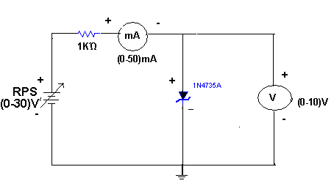

REGULATION CHARACTERISTICS:-

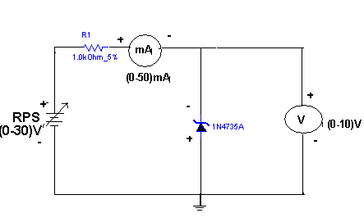
Theory:-
A zener diode is heavily doped p-n junction diode, specially made to operate in the break down region. A p-n junction diode normally does not conduct when reverse biased. But if the reverse bias is increased, at a particular voltage it starts conducting heavily. This voltage is called Break down Voltage. High current through the diode can permanently damage the device
To avoid high current, we connect a resistor in series with zener diode. Once the diode starts conducting it maintains almost constant voltage across the terminals what ever may be the current through it, i.e., it has very low dynamic resistance. It is used in voltage regulators.

PROCEDURE:-

Static characteristics:-

1. Connections are made as per the circuit diagram.
2. The Regulated power supply voltage is increased in steps.
3. The zener current (lz), and the zener voltage (Vz.) are observed and then
noted in the tabular form.
4. A graph is plotted between zener current (Iz) and zener voltage (Vz).

Regulation characteristics:-

1. The voltage regulation of any device is usually expressed as percentage regulation
2. The percentage regulation is given by the formula
((V_{NL}-V_{FL})/V_{FL})X100
V_{NL}=Voltage across the diode, when no load is connected.
V_{FL}=Voltage across the diode, when load is connected.
3. Connection are made as per the circuit diagram
4. The load is placed in full load condition and the zener voltage (Vz), Zener current (lz), load current (I_{L}) are measured.
5. The above step is repeated by decreasing the value of the load in steps.
6. All the readings are tabulated.
7. The percentage regulation is calculated using the above formula

OBSERVATIONS:-

Static characteristics:-

S.NO | ZENER  VOLTAGE(V_{Z}) | ZENER CURRENT(I_{Z})

Regulation characteristics:-

S.N0 | V_{NL}(VOLTS) | V_{FL} (VOLTS) | R_{L} (KΏ) | % REGULATION

MODEL WAVEFORMS:-

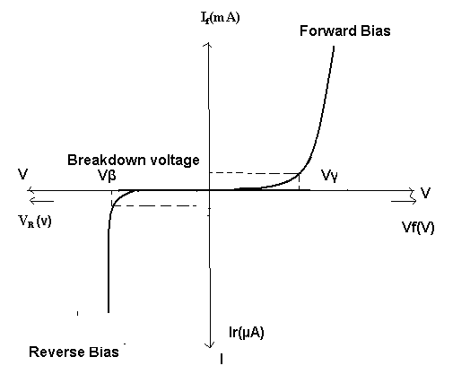

PRECAUTIONS:-
- The terminals of the zener diode should be properly identified
- While determined the load regulation, load should not be immediately shorted.
- Should be ensured that the applied voltages & currents do not exceed the ratings of the diode.

RESULT:-

a) Static characteristics of zener diode are obtained and drawn.
b) Percentage regulation of zener diode is calculated.

VIVAQUESTIONS:-
- What type of temp? Coefficient does the zener diode have?
- If the impurity concentration is increased, how the depletion width effected?
- Does the dynamic impendence of a zener diode vary?
- Explain briefly about avalanche and zener breakdowns?
- Draw the zener equivalent circuit?
- Differentiate between line regulation & load regulation?
- In which region zener diode can be used as a regulator?
- How the breakdown voltage of a particular diode can be controlled?
- What type of temperature coefficient does the Avalanche breakdown has?
- By what type of charge carriers the current flows in zener and avalanche breakdown diodes?

3. TRANSISTOR COMMON -BASE CONFIGURATION
AIM: 1.To observe and draw the input and output characteristics of a transistor connected in common base configuration.
2. To find α of the given transistor.

APPARATUS: Transistor, BC 107
Regulated power supply (0-30V, 1A)
Voltmeter (0-20V)
Ammeters (0-100mA)
Resistor, 1000Ω
Bread board
Connecting wires
THEORY:

A transistor is a three terminal active device. T he terminals are emitter, base, collector. In CB configuration, the base is common to both input (emitter) and output (collector). For normal operation, the E-B junction is forward biased and C-B junction is reverse biased.
In CB configuration, I_{E} is +ve, I_{C} is –ve and I_{B} is –ve. So,
V_{EB=}f1 (V_{CB,}I_{E}) and
I_{C=}f2 (V_{CB,}I_{B)}
With an increasing the reverse collector voltage, the space-charge width at the output junction increases and the effective base width ‘W’ decreases. This phenomenon is known as “Early effect”. Then, there will be less chance for recombination within the base region. With increase of charge gradient with in the base region, the current of minority carriers injected across the emitter junction increases.The current amplification factor of CB configuration is given by,
α= ∆I_{C}/ ∆I_{E}

CIRCUIT DIAGRAM

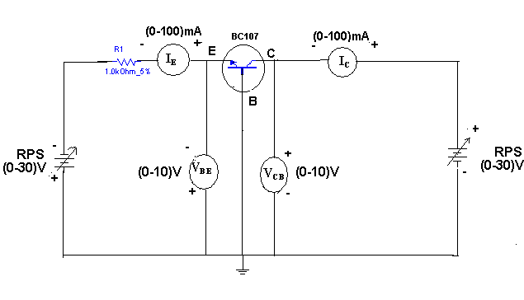

PROCEDURE:
INPUT CHARACTERISTICS:

1. Connections are made as per the circuit diagram.
2. For plotting the input characteristics, the output voltage V_{CE} is kept constant at 0V and for different values of V_{EB} note down the values of I_{E}.
3. Repeat the above step keeping V_{CB} at 2V, 4V, and 6V.All the readings are tabulated.
4. A graph is drawn between V_{EB} and I_{E} for constant V_{CB.}

OUTPUT CHARACTERISTICS:

- Connections are made as per the circuit diagram.
- For plotting the output characteristics, the input I_{E} iskept constant at 10m A and for different values of V_{CB}, note down the values of I_{C.}
- Repeat the above step for the values of I_{E} at 20 mA, 40 mA, and 60 mA, all the readings are tabulated.
- A graph is drawn between V_{CB} and Ic for constant I_{E}

OBSERVATIONS:
INPUT CHARACTERISTICS:

S.No | V_{CB=}0V |  | V_{CB=}1V |  | V_{CB}=2V
S.No | V_{EB}(V) | I_{E(}mA) | V_{EB}(V) | I_{E(}mA) | V_{EB}(V) | I_{E(}mA)

OUTPUT CHARACTERISTICS:

S.No | I_{E=}10mA |  | I_{E=}20mA |  | I_{E}=30mA
S.No | V_{CB}(V) | I_{C(}mA) | V_{CB}(V) | I_{C(}mA) | V_{CB}(V) | I_{C(}mA)

MODEL GRAPHS:
INPUT CHARACTERISTICS

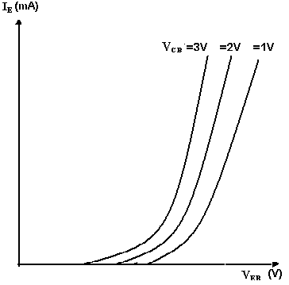

OUTPUT CHARACTERISTICS

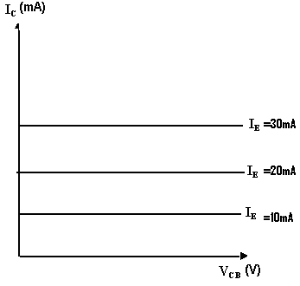
PRECAUTIONS:

- The supply voltages should not exceed the rating of the transistor.
- Meters should be connected properly according to their polarities.

RESULT:
- The input and output characteristics of the transistor are drawn.
- The α of the given transistor is calculated.

VIVA QUESTIONS:
- What is the range of α for the transistor?
- Draw the input and output characteristics of the transistor in CB configuration?
- Identify various regions in output characteristics?
- What is the relation between α and β?
- What are the applications of CB configuration?
- What are the input and output impedances of CB configuration?
- Define α(alpha)?
- What is EARLY effect?
- Draw diagram of CB configuration for PNP transistor?
- What is the power gain of CB configuration?

4. TRANSISTOR CE CHARACTERSTICS
AIM: 1. To draw the input and output characteristics of transistor connected in
CE configuration
2. To find β of the given transistor.
APPARATUS:
Transistor (BC 107)
R.P.S (O-30V) 2Nos
Voltmeters (0-20V) 2Nos
Ammeters (0-200μA)
(0-500mA)
Resistors 1Kohm
Bread board
THEORY:
A transistor is a three terminal device. The terminals are emitter, base, collector. In common emitter configuration, input voltage is applied between base and emitter terminals and out put is taken across the collector and emitter terminals.
Therefore the emitter terminal is common to both input and output.
The input characteristics resemble that of a forward biased diode curve. This is expected since the Base-Emitter junction of the transistor is forward biased. As compared to CB arrangement I_{B} increases less rapidly with V_{BE .} Therefore input resistance of CE circuit is higher than that of CB circuit.
The output characteristics are drawn between I_{c} and V_{CE} at constant I_{B.} the collector current varies with V_{CE} unto few volts only. After this the collector current becomes almost constant, and independent of V_{CE.} The value of V_{CE} up to which the collector current changes with V _{CE} is known as Knee voltage. The transistor always operated in the region above Knee voltage, I_{C} is always constant and is approximately equal to I_{B.}
The current amplification factor of CE configuration is given by
Β = ΔI_{C}/ΔI_{B}
CIRCUIT DIAGRAM:
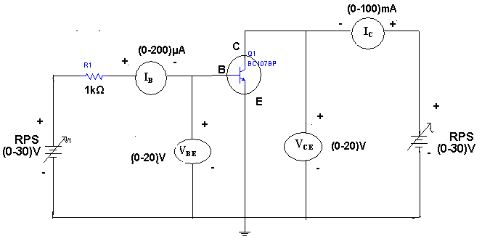
PROCEDURE:

INPUT CHARECTERSTICS:
- Connect the circuit as per the circuit diagram.
- For plotting the input characteristics the output voltage V_{CE} is kept constant at 1V and for different values of V_{BE} . Note down the values of I_{C}
- Repeat the above step by keeping V_{CE} at 2V and 4V.
- Tabulate all the readings.
- plot the graph between V_{BE} and I_{B} for constant V_{CE}

OUTPUT CHARACTERSTICS:
- Connect the circuit as per the circuit diagram
- for plotting the output characteristics the input current I_{B} is kept constant at 10μA and for different values of V_{CE} note down the values of I_{C}
- repeat the above step by keeping IB at 75 μA 100 μA
- tabulate the all the readings
- plot the graph between V_{CE} and I_{C} for constant I_{B}

OBSERVATIONS:

INPUT CHARACTERISTICS:

S.NO | V_{CE} = 1V |  | V_{CE} = 2V |  | V_{CE} = 4V
S.NO | V_{BE}(V) | I_{B}(μA) | V_{BE}(V) | I_{B}(μA) | V_{BE}(V) | I_{B}(μA)

OUT PUT CHAREACTARISTICS:

S.NO | I_{B} = 50 μA |  | I_{B} = 75 μA |  | I_{B} = 100 μA
S.NO | V_{CE}(V) | I_{C}(mA) | V_{CE}(V) | I_{C}mA) | V_{CE}(V) | I_{C}(mA)

MODEL GRAPHS:
INPUT CHARACTERSTICS:

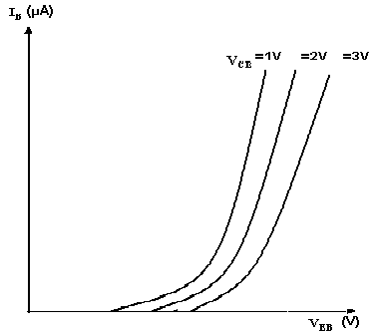

OUTPUT CHARECTERSTICS:
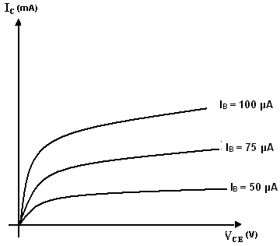

PRECAUTIONS:
1. The supply voltage should not exceed the rating of the transistor
2. Meters should be connected properly according to their polarities

RESULT:
- the input and out put characteristics of a transistor in CE configuration are Drawn
- the  of a given transistor is calculated

VIVA QUESTIONS:
- What is the range of for the transistor?
- What are the input and output impedances of CE configuration?
- Identify various regions in the output characteristics?
- what is the relation between 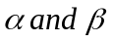
- Define current gain in CE configuration?
- Why CE configuration is preferred for amplification?
- What is the phase relation between input and output?
- Draw diagram of CE configuration for PNP transistor?
- What is the power gain of CE configuration?
- What are the applications of CE configuration?

5. HALF – WAVE RECTIFIER

AIM: - To obtain the load regulation and ripple factor of a half-rectifier.
1. with Filter
2. without Filter
APPARATUS:-
Experimental Board
Multimeters –2No’s.
Transformer (6-0-6).
Diode, 1N 4007
Capacitor 100μf.
Resistor 1KΩ.
Connecting wires
THEORY: -
During positive half-cycle of the input voltage, the diode D1 is in forward bias and conducts through the load resistor R1. Hence the current produces an output voltage across the load resistor R1, which has the same shape as the +ve half cycle of the input voltage.
During the negative half-cycle of the input voltage, the diode is reverse biased and there is no current through the circuit. i.e, the voltage across R1 is zero. The net result is that only the +ve half cycle of the input voltage appears across the load. The average value of the half wave rectified o/p voltage is the value measured on dc voltmeter.
For practical circuits, transformer coupling is usually provided for two reasons.
1. The voltage can be stepped-up or stepped-down, as needed.
2. The ac source is electrically isolated from the rectifier. Thus preventing shock hazards in the secondary circuit.

CIRCUIT DIAGRAM:-

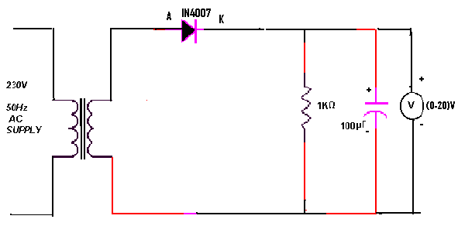

PROCEDURE:-
1. Connections are made as per the circuit diagram.
2. Connect the primary side of the transformer to ac mains and the secondary side to the rectifier input.
3. By the multimeter, measure the ac input voltage of the rectifier and, ac and dc voltage at the output of the rectifier.
4. Find the theoretical of dc voltage by using the formula,

Vdc=Vm/П

Where, Vm=2Vrms, (Vrms=output ac voltage.)
The Ripple factor is calculated by using the formula
r=ac output voltage/dc output voltage.

REGULATION CHARACTERSTICS:-
- Connections are made as per the circuit diagram.
- By increasing the value of the rheostat, the voltage across the load and current flowing through the load are measured.
- The reading is tabulated.
- Draw a graph between load voltage (V_{L} and load current ( I_{L} ) taking V_{L} on X-axis and I_{L} on y-axis
- From the value of no-load voltages, the %regulation is calculated using the formula,

Theoretical calculations for Ripple factor:-

Without Filter:-
Vrms=Vm/2
Vm=2Vrms
Vdc=Vm/П
Ripple factor r=√ (Vrms/ Vdc )² -1 =1.21
With Filter:-
Ripple factor, r=1/ (2√3 f C R)
Where f =50Hz
C =100µF
R_{L}=1KΩ

PRACTICAL CALCULATIONS:-

Vac=
Vdc=
Ripple factor with out Filter =
Ripple factor with Filter =

OBSERVATIONS:-

WITHOUT FILTER

USING DMM | V_{ac}(v) | V_{dc}(v) | r= V_{ac}/ V_{dc}

WITH FILTER

USING DMM | V_{ac}(v) | V_{dc}(v) | r= V_{ac}/ V_{dc}

WITHOUTFILTER:-
Vdc=Vm/П, Vrms=Vm/2, Vac=√ ( Vrms²- Vdc ²)

USING CRO | V_{m}(v) | V_{ac}(v) | V_{dc}(v) | r= V_{ac}/ V_{dc}

WITHFILTER
USINGCRO | V₁(V) | V₂(V) | V_{dc}= (V₁+V₂)/2 | V_{ac}=  (V₁₋ V₂)/2√3 | r=  V_{ac}/ V_{dc}

PRECAUTIONS:

1. The primary and secondary sides of the transformer should be carefully identified.
2. The polarities of the diode should be carefully identified.
3. While determining the % regulation, first Full load should be applied and then it should be decremented in steps.

RESULT:-

1. The Ripple factor for the Half-Wave Rectifier with and without filters is measured.
2. The % regulation of the Half-Wave rectifier is calculated.

VIVA QUESTIONS:
1. What is the PIV of Half wave rectifier?
2. What is the efficiency of half wave rectifier?
3. What is the rectifier?
4. What is the difference between the half wave rectifier and full wave
Rectifier?
5. What is the o/p frequency of Bridge Rectifier?
6. What are the ripples?
7. What is the function of the filters?
8. What is TUF?
9. What is the average value of o/p voltage for HWR?
10. What is the peak factor?

6. FULL-WAVE RECTIFIER
AIM:-To find the Ripple factor and regulation of a Full-wave Rectifier with and without filter.
APPARATUS:-
Experimental Board
Transformer (6-0-6v).
P-n Diodes, (lN4007) ---2 No’s
Multimeters –2No’s
Filter Capacitor (100μF/25v) -
Connecting Wires
Load resistor, 1KΩ

THEORY:-
The circuit of a center-tapped full wave rectifier uses two diodes D1&D2. During positive half cycle of secondary voltage (input voltage), the diode D1 is forward biased and D2is reverse biased.
The diode D1 conducts and current flows through load resistor R_{L}. During negative half cycle, diode
D2 becomes forward biased and D1 reverse biased. Now, D2 conducts and current flows through the load resistor R_{L} in the same direction. There is a continuous current flow through the load resistor R_{L}, during both the half cycles and will get unidirectional current as show in the model graph. The difference between full wave and half wave rectification is that a full wave rectifier allows unidirectional (one way) current to the load during the entire 360 degrees of the input signal and half-wave rectifier allows this only during one half cycle (180 degree).

CIRCUIT DIAGRAM:-

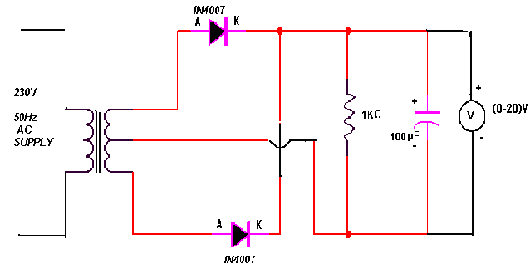
PROCEDURE:

  - Connections are made as per the circuit diagram.
- Connect the ac mains to the primary side of the transformer and the secondary side to the rectifier.
- Measure the ac voltage at the input side of the rectifier.
- Measure both ac and dc voltages at the output side the rectifier.
- Find the theoretical value of the dc voltage by using the formula Vdc=2Vm/П
- Connect the filter capacitor across the load resistor and measure the values of Vac and Vdc at the output.
- The theoretical values of Ripple factors with and without capacitor are calculated.
- From the values of Vac and Vdc practical values of Ripple factors are calculated. The practical values are compared with theoretical values.

THEORITICAL CALCULATIONS:-

Vrms = Vm/ √2
Vm =Vrms√2
Vdc=2Vm/П
(i)Without filter:
Ripple factor, r = √ ( Vrms/ Vdc )² -1 = 0.482
(ii)With filter:

Ripple factor, r = 1/ (4√3 f C R_{L}) where f =50Hz
C =100µF
R_{L}=1KΩ
PRACTICAL CALCULATIONS:

Without filter:-
Vac=
Vdc=
Ripple factor, r=Vac/Vdc
With filters:-
Vac=
Vdc=
Ripple factor=Vac/Vdc

Without Filter:
USING DMM | V_{ac}(v) | V_{dc}(v) | r= V_{ac}/ V_{dc}

With Filter

USING DMM | V_{ac}(v) | V_{dc}(v) | r= V_{ac}/ V_{dc}

Without Filter

Vrms = Vm/ √2 , Vdc=2Vm/П , Vac=√( Vrms²- Vdc ²)

USING CRO | V_{m}(v) | V_{ac}(v) | V_{dc}(v) | r= V_{ac}/ V_{dc}

With Filter
USINGCRO | V₁(V) | V₂(V) | V_{dc}= (V₁+V₂)/2 | V_{ac}=  (V₁₋ V₂)/2√3 | r=  V_{ac}/ V_{dc}

PRECAUTIONS:

- The primary and secondary side of the transformer should be carefully identified
- The polarities of all the diodes should be carefully identified.

RESULT:-
The ripple factor of the Full-wave rectifier (with filter and without filter) is calculated.

VIVA QUESTIONS:-
- Define regulation of the full wave rectifier?
- Define peak inverse voltage (PIV)? And write its value for Full-wave rectifier?
- If one of the diode is changed in its polarities what wave form would you get?
- Does the process of rectification alter the frequency of the waveform?
- What is ripple factor of the Full-wave rectifier?
- What is the necessity of the transformer in the rectifier circuit?
- What are the applications of a rectifier?
- What is ment by ripple and define Ripple factor?
- Explain how capacitor helps to improve the ripple factor?
- Can a rectifier made in INDIA (V=230v, f=50Hz) be used in USA (V=110v, f=60Hz)?

7. FET CHARACTERISTICS

AIM: a). To draw the drain and transfer characteristics of a given
FET.
b). To find the drain resistance (r_{d}) amplification factor (μ) and
Tran conductance (g_{m}) of the given FET.

APPARATUS: FET (BFW-11)
Regulated power supply
Voltmeter (0-20V)
Ammeter (0-100mA)
Bread board
Connecting wires
THEORY:
A FET is a three terminal device, having the characteristics of high input impedance and less noise, the Gate to Source junction of the FET s always reverse biased. In response to small applied voltage from drain to source, the n-type bar acts as sample resistor, and the drain current increases linearly with V_{DS.} With increase in I_{D} the ohmic voltage drop between the source and the channel region reverse biases the junction and the conducting position of the channel begins to remain constant. The V_{DS} at this instant is called “pinch of voltage”.
If the gate to source voltage (V_{GS}) is applied in the direction to provide additional reverse bias, the pinch off voltage ill is decreased.
In amplifier application, the FET is always used in the region beyond the pinch-off.
F_{DS}=I_{DSS}(1-V_{GS}/V_{P})^2

CIRCUIT DIAGRAM
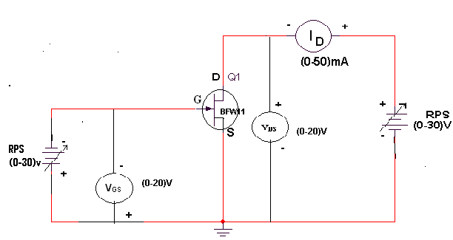
PROCEDURE:
- All the connections are made as per the circuit diagram.
- To plot the drain characteristics, keep V_{GS} constant at 0V.
- Vary the V_{DD} and observe the values of V_{DS} and I_{D}.
- Repeat the above steps 2, 3 for different values of V_{GS} at 0.1V and 0.2V.
- All the readings are tabulated.
- To plot the transfer characteristics, keep V_{DS} constant at 1V.
- Vary V_{GG} and observe the values of V_{GS} and I_{D}.
- Repeat steps 6 and 7 for different values of V_{DS} at 1.5 V and 2V.
- The readings are tabulated.
- From drain characteristics, calculate the values of dynamic resistance (r_{d}) by using the formula
r_{d =} ∆V_{DS}/∆I_{D}
- From transfer characteristics, calculate the value of transconductace (g_{m}) By using the formula
G_{m=}∆I_{D}/∆V_{DS}
- Amplification factor (μ) = dynamic resistance. Tran conductance
μ = ∆V_{DS}/∆V_{GS}
OBSERVATIONS:

DRAIN CHARACTERISTICS:

S.NO | V_{GS}=0V |  | V_{GS}=0.1V |  | V_{GS=}0.2V
 | V_{DS}(V) | I_{D}(mA) | V_{DS}(V) | I_{D}(mA) | V_{DS}(V) | I_{D}(mA)

TRANSFER CHARACTERISTICS:

S.NO | V_{DS} =0.5V |  | V_{DS}=1V |  | V_{DS} =1.5V
 | V_{GS} (V) | I_{D}(mA) | V_{GS} (V) | I_{D}(mA) | V_{GS} (V) | I_{D}(mA)

MODEL GRAPH:

TRANSFER CHARACTERISTICS
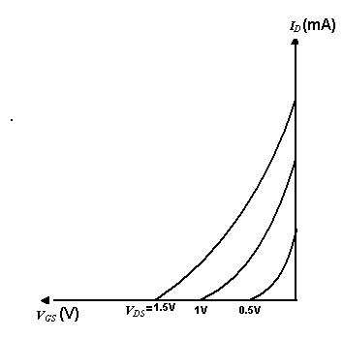
DRAIN CHARACTERISTICS

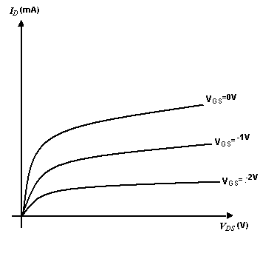
PRECAUTIONS:

- The three terminals of the FET must be care fully identified
- Practically FET contains four terminals, which are called source, drain, Gate, substrate.
- Source and case should be short circuited.
- Voltages exceeding the ratings of the FET should not be applied.

RESULT :

- The drain and transfer characteristics of a given FET are drawn
- The dynamic resistance (r_{d}), amplification factor (μ) and Tran conductance (g_{m}) of the given FET are calculated.

VIVA QUESTIONS:
- What are the advantages of FET?
- Different between FET and BJT?
- Explain different regions of V-I characteristics of FET?
- What are the applications of FET?
- What are the types of FET?
- Draw the symbol of FET.
- What are the disadvantages of FET?
- What are the parameters of FET?

8. h-PARAMETERS OF CE CONFIGURATION
AIM: To calculate the H-parameters of transistor in CE configuration.
APPRATUS: Transistor BC 107
Resistors 100 K Ώ 100 Ώ
Ammeter (0-200µA), (0-200mA)
Voltmeter (0-20V) - 2Nos
Regulated Power Supply (0-30V, 1A) - 2Nos
Breadboard
THEORY:
INPUT CHARACTERISTICS:
The two sets of characteristics are necessary to describe the behavior of the CE configuration one for input or base emitter circuit and other for the output or collector emitter circuit.
In input characteristics the emitter base junction forward biased by a very small voltage V_{BB} where as collector base junction reverse biased by a very large voltage V_{CC}. The input characteristics are a plot of input current I_{B} V_{s} the input voltage V_{BE} for a range of values of output voltage V_{CE} . The following important points can be observed from these characteristics curves.
- The characteristics resemble that of CE configuration.
- Input resistance is high as I_{B} increases less rapidly with V_{BE}
- The input resistance of the transistor is the ratio of change in base emitter voltage ΔV_{BE} to change in base current ΔI_{B} at constant collector emitter voltage ( V_{CE)} i.e... Input resistance or input impedance hie = ΔV_{BE} / ΔI_{B} at V_{CE} constant.

OUTPUT CHARACTERISTICS:
A set of output characteristics or collector characteristics are a plot of out put current I_{C} V_{S} output voltage V_{CE} for a range of values of input current I_{B} .The following important points can be observed from these characteristics curves:-
1. The transistor always operates in the active region. I.e. the collector current
I_{C} increases with V_{CE} very slowly. For low values of the V_{CE} the I_{C} increases rapidly with a small increase in V_{CE} .The transistor is said to be working in saturation region.
Output resistance is the ratio of change of collector emitter voltage ΔV_{CE ,} to change in collector current ΔI_{C} with constant I_{B.} Output resistance or Output impedance hoe = ΔV_{CE} / ΔI_{C} at I_{B} constant.
Input Impedance hie = ΔV_{BE} / ΔI_{B} at V_{CE} constant
Output impedance hoe = ΔV_{CE} / ΔI_{C} at I_{B} constant
Reverse Transfer Voltage Gain hre = ΔV_{BE} / ΔV_{CE} at I_{B} constant
Forward Transfer Current Gain hfe = ΔI_{C} / ΔI_{B} at constant V_{CE}

CIRCUIT DIAGRAM:
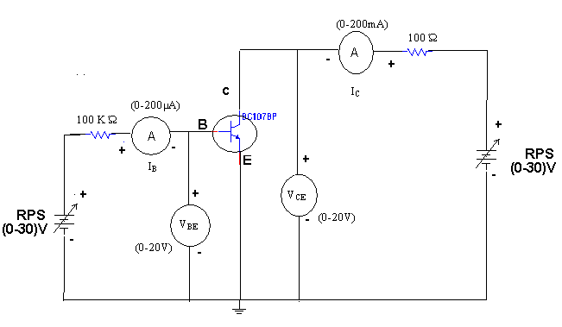
PROCEDURE:
- Connect a transistor in CE configuration circuit for plotting its input and output characteristics.
- Take a set of readings for the variations in I_{B} with V_{BE} at different fixed values of output voltage V_{CE} .
- Plot the input characteristics of CE configuration from the above readings.
- From the graph calculate the input resistance hie and reverse transfer ratio hre by taking the slopes of the curves.
- Take the family of readings for the variations of I_{C} with V_{CE} at different values of fixed I_{B.}
- Plot the output characteristics from the above readings.
- From the graphs calculate hfe ands hoe by taking the slope of the curves.
Tabular Forms
Input Characteristics
S.NO | V_{CE}=0V |  | V_{CE}=6V
S.NO | V_{BE}(V) | I_{B}(μA) | V_{BE}(V) | I_{B}(μA)

Output Characteristics
S.NO | I_{B} = 20 µA |  | I_{B} = 40 µA |  | I_{B} = 60 µA
S.NO | V_{CE} (V) | I_{C}(mA) | V_{CE} (V) | I_{C}(mA) | V_{CE} (V) | I_{C}(mA)

MODEL WAVEFORM: Input Characteristics
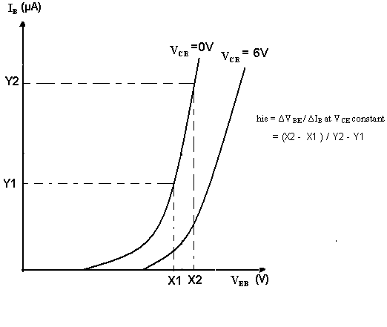
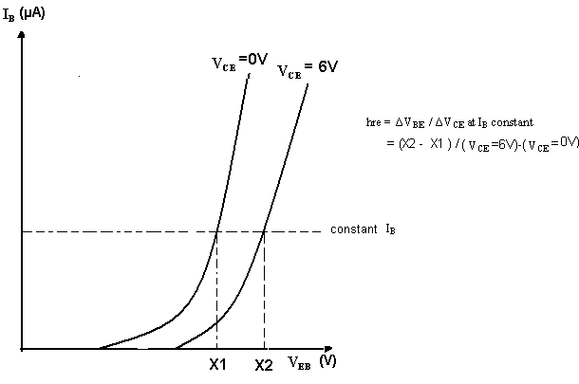
Output Characteristics
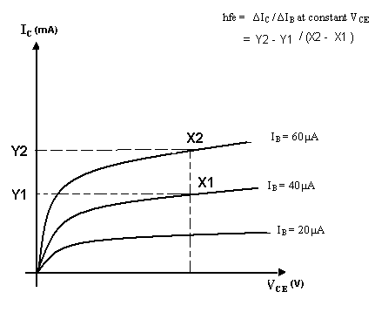

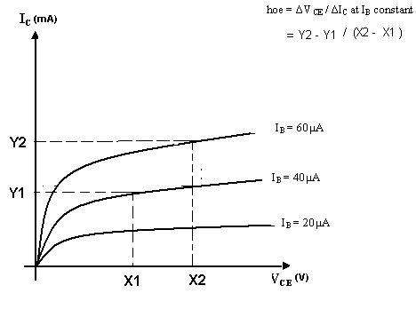
RESULT: The H-Parameters for a transistor in CE configuration are calculated from the input and output characteristics.
- Input Impedance hie =
- Reverse Transfer Voltage Gain hre =
- Forward Transfer Current Gain hfe =
- Output conductance hoe =
VIVA QUESTIONS:
- What are the h-parameters?
- What are the limitations of h-parameters?
- What are its applications?
- Draw the Equivalent circuit diagram of H parameters?
- Define H parameter?
- What are tabular forms of H parameters monoculture of a transistor?
- What is the general formula for input impedance?
- What is the general formula for Current Gain?
- What is the general formula for Voiltage gain?

9. TRANSISTOR CE AMPLIFIER

AIM: 1. To Measure the voltage gain of a CE amplifier
2. To draw the frequency response curve of the CE amplifier

APPARATUS:
Transistor BC-107
Regulated power Supply (0-30V, 1A)
Function Generator
CRO
Resistors [33KΩ, 3.3KΩ, 330Ω, 1.5KΩ
1KΩ, 2.2KΩ, 4.7KΩ]
Capacitors- 10µF -2No
100µF
Bread Board
Connecting Wires

THEORY:
The CE amplifier provides high gain &wide frequency response. The emitter lead is common to both input & output circuits and is grounded. The emitter-base circuit is forward biased. The collector current is controlled by the base current rather than emitter current. The input signal is applied to base terminal of the transistor and amplifier output is taken across collector terminal. A very small change in base current produces a much larger change in collector current. When +VE half-cycle is fed to the input circuit, it opposes the forward bias of the circuit which causes the collector current to decrease, it decreases the voltage more –VE. Thus when input cycle varies through a -VE half-cycle, increases the forward bias of the circuit, which causes the collector current to increases thus the output signal is common emitter amplifier is in out of phase with the input signal.
CIRCUIT DIAGRAM:
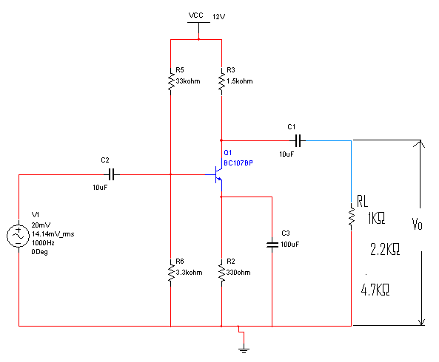
PROCEDURE:

- Connect the circuit as shown in circuit diagram
- Apply the input of 20mV peak-to-peak and 1 KHz frequency using Function Generator
- Measure the Output Voltage Vo (p-p) for various load resistors
- Tabulate the readings in the tabular form.
- The voltage gain can be calculated by using the expression A_{v}= (V₀/V_{i})
- For plotting the frequency response the input voltage is kept Constant at 20mV peak-to-peak and the frequency is varied from 100Hz to 1MHz Using function generator
- Note down the value of output voltage for each frequency.
- All the readings are tabulated and voltage gain in dB is calculated by Using The expression A_{v}=20 log₁₀ (V₀/V_{i})
- A graph is drawn by taking frequency on x-axis and gain in dB on y-axis
On Semi-log graph.
The band width of the amplifier is calculated from the graph
Using the expression,
Bandwidth, BW=f₂-f₁
Where f₁ lower cut-off frequency of CE amplifier, and
Where f₂ upper cut-off frequency of CE amplifier
The bandwidth product of the amplifier is calculated using the
Expression
Gain Bandwidth product=3-dBmidband gain X Bandwidth

OBSERVATIONS:

Input voltage Vi=20mV

LOAD RESISTANCE(KΩ) | OUTPUT VOLTAGE (V₀) | GAIN  A_{V=}(V₀/V_{i}) | GAIN IN dB  A_{v}=20log₁₀ (V₀/V_{i})

FREQUENCY RESPONSE: Vi=20mv
FREQUENCY(Hz) | OUTPUT  VOLTAGE (V₀) | GAIN IN dB  A_{v}=20 log₁₀ (V₀/V_{i})

MODELWAVE FORMS:

INPUT WAVE FORM:

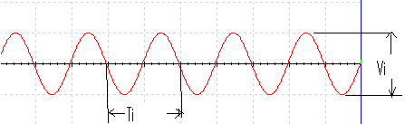

OUTPUT WAVE FORM

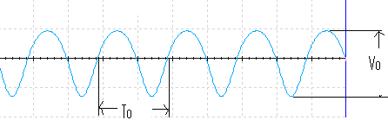

FREQUENCY RESPONSE
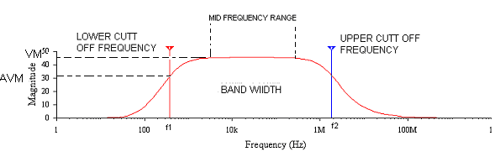

RESULT: The voltage gain and frequency response of the CE amplifier are obtained. Also gain bandwidth product of the amplifier is calculated.

VIVA QUESTIONS:

- What is phase difference between input and output waveforms of CE amplifier?
- What type of biasing is used in the given circuit?
- If the given transistor is replaced by a p-n-p, can we get output or not?
- What is effect of emitter-bypass capacitor on frequency response?
- What is the effect of coupling capacitor?
- What is region of the transistor so that it is operated as an amplifier?
- How does transistor acts as an amplifier?
- Draw the h-parameter model of CE amplifier?
- What type of transistor configuration is used in intermediate stages of a multistage amplifier?
- What is Early effect?

10. COMMON COLLECTOR AMPLIFIER

AIM: 1. To measure the voltage gain of a CC amplifier
2. To draw the frequency response of the CC amplifier

APPRATUS:
Transistor BC 107
Regulated Power Supply (0-30V)
Function Generator
CRO
Resistors 33KΩ, 3.3KΩ, 330Ω, 1.5KΩ, 1KΩ, 2.2KΩ & 4.7KΩ

Capacitors 10µF -2Nos
100µF
Breadboard
Connecting wires

THEORY:
In common-collector amplifier the input is given at the base and the output is taken at the emitter. In this amplifier, there is no phase inversion between input and output. The input impedance of the CC amplifier is very high and output impedance is low. The voltage gain is less than unity. Here the collector is at ac ground and the capacitors used must have a negligible reactance at the frequency of operation.
This amplifier is used for impedance matching and as a buffer amplifier. This circuit is also known as emitter follower.

CIRCUIT DIAGRAM:
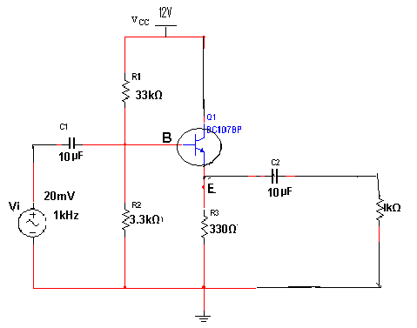
PROCEDURE:
- Connections are made as per the circuit diagram.
- For calculating the voltage gain the input voltage of 20mV peak-to-peak and 1 KHz frequency is applied and output voltage is taken for various load resistors.
- The readings are tabulated.
The voltage gain calculated by using the expression, A_{v}=V₀/V_{i}
- For plotting the frequency response the input voltage is kept constant a
20mV peak-to- peak and the frequency is varied from 100Hzto 1MHz.
- Note down the values of output voltage for each frequency.
All the readings are tabulated the voltage gain in dB is calculated by using the expression, A_{v}=20log 10(V0/V_{i})
- A graph is drawn by taking frequency on X-axis and gain in dB on y-axis on
Semi-log graph sheet.
The Bandwidth of the amplifier is calculated from the graph using the
Expression,
Bandwidth BW=f₂-f₁
Where f₁ is lower cut-off frequency of CE amplifier
f₂ is upper cut-off frequency of CE amplifier
10. The gain Bandwidth product of the amplifier is calculated using the
Expression,
Gain -Bandwidth product=3-dB midband gain X Bandwidth

OBSERVATIONS:

LOAD RESISTANCE(KΩ) | OUTPUT VOLTAGE( V₀) | GAIN A_{v}=V₀/V_{i} | GAIN IN dB A_{v}=20log 10(V0/V_{i})

FREQUENCY RESPONSE:
V_{i}=20mV
FREQUENCY(Hz) | OUTPUT  VOLTAGE( V₀) | GAIN IN dB A_{v}=20log 10(V0/V_{i})

WAVEFORM:

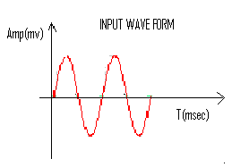

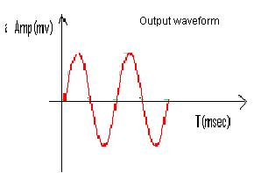

PRECAUTIONS:

1. The input voltage must be kept constant while taking frequency response.
2. Proper biasing voltages should be applied.

RESULT:
The voltage gain and frequency response of the CC amplifier are obtained. Also gain Bandwidth product is calculated.

VIVA QUESTIONS:

- What are the applications of CC amplifier?
- What is the voltage gain of CC amplifier?
- What are the values of input and output impedances of the CC amplifier?
- To which ground the collector terminal is connected in the circuit?
- Identify the type of biasing used in the circuit?
- Give the relation between α, β and γ.
- Write the other name of CC amplifier?
- What are the differences between CE,CB and CC?
- When compared to CE, CC is not used for amplification. Justify your answer?
- What is the phase relationship between input and output in CC?

11. RC COUPLED AMPLIFIER
AIM: To calculate voltage gain, to observe frequency response.

APPARATUS:
Transistors - BC 107 -2Nos,
Resistors - 3.3K -2Nos,
33k -2Nos,
330Ω -2Nos,
1k -2Nos,
Capacitors - 100uF -3Nos,
10uF -2Nos,
Bread Board,
Regulated power supply,
Cathode ray oscilloscope,

THEORY:
This is most popular type of coupling as it provides excellent audio fidelity.
A coupling capacitor is used to connect output of first stage to input of second stage. Resistances R1, R2,Re form biasing and stabilization network. Emitter bypass capacitor offers low reactance paths to signal coupling Capacitor transmits ac signal, blocks DC. Cascade stages amplify signal and overall gain is increased total gain is less than product of gains of individual stages. Thus for more gain coupling is done and overall gain of two stages equals to A=A1*A2
A1=voltage gain of first stage
A2=voltage gain of second stage.
When ac signal is applied to the base of the transistor, its amplified output appears across the collector resistor Rc.It is given to the second stage for further amplification and signal appears with more strength. Frequency response curve is obtained by plotting a graph between frequency and gain in db .The gain is constant in mid frequency range and gain decreases on both sides of the mid frequency range. The gain decreases in the low frequency range due to coupling capacitor Cc and at high frequencies due to junction capacitance Cbe.
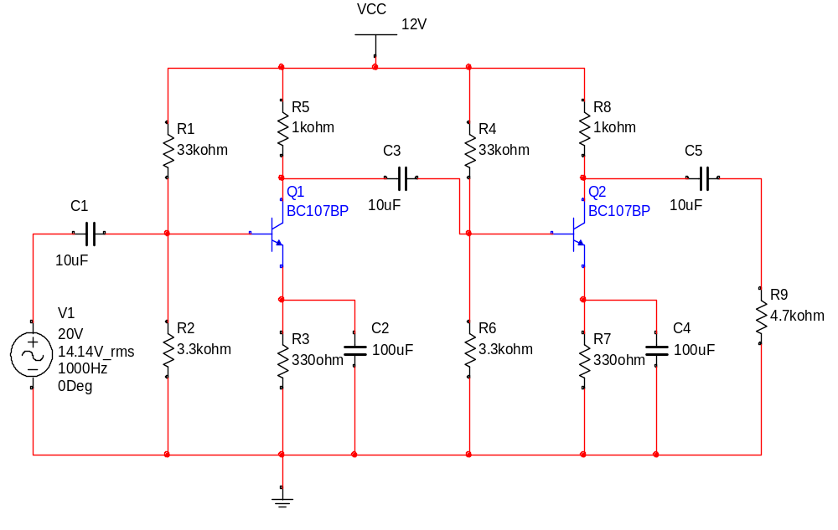CIRCUIT DIAGRAM:

PROCEDURE:
- Apply input by using function generator to the circuit.
- Observe the output waveform on CRO.
- Measure the voltage at
  - Output of first stage
  - Output of second stage.
- From the readings calculate voltage gain of first stage, second stage and overall gain of two stages. Disconnect second stage and then measure output voltage of first stage calculate voltage gain.
- Compare it with voltage gain obtained when second stage was connected.
- Note down various values of gain for different frequencies.
- A graph is plotted between frequency and voltage gain.

OBSERVATIONS: -

APPLIED FREQUENCY | O/P VOLTAGE  (Vo) | VOLTAGE GAIN  in dB (20 log₁₀Vo/Vi)

MODELGRAPH:-
INPUT WAVE FORM:

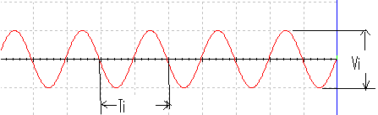

FIRST STAGE OUTPUT:
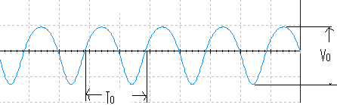

SECOND STAGE OUTPUT:
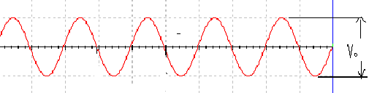

FREQUENCY RESPONSE:

PRECAUTIONS:
  - All connections should be tight.
  - Transistor terminals must be identifying properly.
  - Reading should be taken with out any parallax error.

RESULT: Thus voltage gain is calculated and frequency response is observed along with loading affect.

VIVA QUESTIONS:

  - What is the necessity of cascading?
  - What is 3dB bandwidth?
  - Why RC coupling is preferred in audio range?
  - Which type of coupling is preferred and why?
  - Explain various types of Capacitors?
  - What is loading effect?
  - Why it is known as RC coupling?
  - What is the purpose of emitter bypass capacitor?
  - Which type of biasing is used in RC coupled amplifier?

12. COMMON SOURCE FET AMPLIFIER

AIM: 1. To obtain the frequency response of the common source FET
Amplifier
2. To find the Bandwidth.
APPRATUS:
N-channel FET (BFW11)
Resistors (6.8KΩ, 1MΩ, 1.5KΩ)
Capacitors (0.1µF, 47µF)
Regulated power Supply (0-30V)
Function generator
CRO
CRO probes
Bread board
Connecting wires

CIRCUIT DIAGRAM:
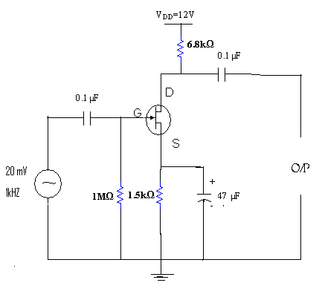

THEORY:
A field-effect transistor (FET) is a type of transistor commonly used for weak-signal amplification (for example, for amplifying wireless (signals). The device can amplify analog or digital signals. It can also switch DC or function as an oscillator. In the FET, current flows along a semiconductor path called the channel. At one end of the channel, there is an electrode called the source. At the other end of the channel, there is an electrode called the drain. The physical diameter of the channel is fixed, but its effective electrical diameter can be varied by the application of a voltage to a control electrode called the gate. Field-effect transistors exist in two major classifications. These are known as the junction FET (JFET) and the metal-oxide- semiconductor FET (MOSFET). The junction FET has a channel consisting of N-type semiconductor (N-channel) or P-type semiconductor (P-channel) material; the gate is made of the opposite semiconductor type. In P-type material, electric charges are carried mainly in the form of electron deficiencies called holes. In N-type material, the charge carriers are primarily electrons. In a JFET, the junction is the boundary between the channel and the gate. Normally, this P-N junction is reverse-biased (a DC voltage is applied to it) so that no current flows between the channel and the gate. However, under some conditions there is a small current through the junction during part of the input signal cycle. The FET has some advantages and some disadvantages relative to the bipolar transistor. Field-effect transistors are preferred for weak-signal work, for example in wireless, communications and broadcast receivers. They are also preferred in circuits and systems requiring high impedance. The FET is not, in general, used for high-power amplification, such as is required in large wireless communications and broadcast transmitters.
Field-effect transistors are fabricated onto silicon integrated circuit (IC) chips. A single IC can contain many thousands of FETs, along with other components such as resistors, capacitors, and diodes.
PROCEDURE:
1. Connections are made as per the circuit diagram.
2. A signal of 1 KHz frequency and 50mV peak-to-peak is applied at the
Input of amplifier.
3. Output is taken at drain and gain is calculated by using the expression,
A_{v}=V₀/V_{i}

4. Voltage gain in dB is calculated by using the expression,
A_{v}=20log 10(V0/V_{i})
5. Repeat the above steps for various input voltages.
6. Plot A_{v} v_{s.} Frequency

7. The Bandwidth of the amplifier is calculated from the graph using the
Expression,
Bandwidth BW=f₂-f₁
Where f₁ is lower 3 dB frequency
f₂ is upper 3 dB frequency

OBSERVATIONS:

S.NO | INPUT  VOLTAGE(V_{i}) | OUTPUT  VOLTAGE(V₀) | VOLTAGE GAIN  A_{v}= (V0/V_{i})

MODEL GRAPH:

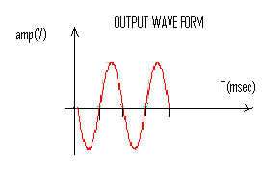
PRECAUTIONS:

1. All the connections should be tight.
2. Transistor terminals must be identified properly
.
RESULT: The frequency response of the common source FET
Amplifier and Bandwidth is obtained.

VIVA QUESTIONS
- What is the difference between FET and BJT?
- FET is unipolar or bipolar?
- Draw the symbol of FET?
- What are the applications of FET?
- FET is voltage controlled or current controlled?
- Draw the equivalent circuit of common source FET amplifier?
- What is the voltage gain of the FET amplifier?
- What is the input impedance of FET amplifier?
- What is the output impedance of FET amplifier?
- What are the FET parameters?
- What are the FET applications?
13. WEIN BRIDGE OSCILLATOR
AIM: To study and calculate frequency of. Wein Bridge Oscillator.

APPARATUS:
Transistor (BC 107) 2 No
Resistors 10K 4 No
1 K 3 No
2.2 K 2 No
33 K
6.8 K
Capacitors 10 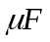 2 No
100
0.01 2 No
RPS (0 – 30 V)
Potentiometer
Bread Boar
CRO
Connecting wires

CIRCUITDIAGRAM: 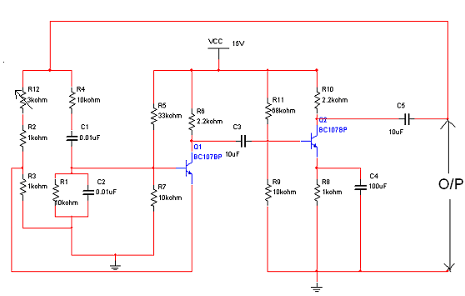
THEORY:
The wein bridge oscillator is a standard circuit for generating low frequencies in the range of 10 Hz to about 1MHz.The method used for getting +ve feedback in wein bridge oscillator is to use two stages of an RC-coupled amplifier. Since one stage of the RC-coupled amplifier introduces a phase shift of 180 deg, two stages will introduces a phase shift of 360 deg. At the frequency of oscillations f the +ve feedback network shown in fig makes the input & output in the phase. The frequency of oscillations is given as
f =1/2π√R₁C₁R₂C₂
In addition to the positive feedback

PROCEDURE:
- Connections are made as per the circuit diagram
- Feed the output of the oscillator to a C.R.O by making adjustments in the Potentiometer connected in the +ve feedback loop, try to obtain a stable sine Wave.
- Measure the time period of the waveform obtained on CRO. & calculate the Frequency of oscillations.
- Repeat the procedure for different values of capacitance.

OBSERVATION:
Given R=10kΩ, C=0.01μF
f_{T} = 1/ 2πRC
f_{P} =  =
Amplitude,V₀ =
MODEL WAVE FORM:
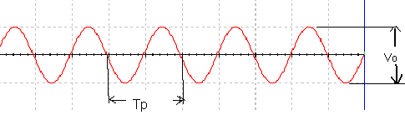

RESULT:
The frequency of the wein bridge oscillator is calculated and is verified

VIVA QUESTIONS:

- Give the formula for frequency of oscillations?
- What is the condition for wien bridge oscillator to generate oscillations?
- What is the total phase shift provided by the oscillator?
- What is the function of lead-lag network in Wein bridge oscillator?
- which type of feedback is used in Wein bridge oscillator
- What is gain of Wein bridge oscillator?
- what are the application of Wein bridge oscillator
- What is the condition for oscillations?
- What is the difference between damped oscillations undamped Oscillations?
- Wein bridge oscillator is either LC or RC oscillator.
14. RC PHASE SHIFT OSCILLATOR

AIM: To calculate the frequency of the RC phase shift oscillator & to measure the phase angles at different RC sections.

APPARATUS:

1. Transistor BC107

2. Resistors: 10KΩ -3Nos

8KΩ or 10KΩ

22KΩ

1.2KΩ

100KΩ

3. Capacitors: 0.001µf – 3 Nos

10µF – 2Nos

1µf

4. Regulated power Supply

5. CRO

THEORY:
RC-Phase shift Oscillator has a CE amplifier followed by three sections of RC phase shift feed back Networks the out put of the last stage is return to the input of the amplifier. The values of R and C are chosen such that the phase shift of each RC section is 60º.Thus The RC ladder network produces a total phase shift of 180º between its input and output voltage for the given frequencies. Since CE Amplifier produces 180 º phases shift the total phase shift from the base of the transistor around the circuit and back to the base will be exactly 360º or 0º. This satisfies the Barkhausen condition for sustaining oscillations and total loop gain of this circuit is greater than or equal to 1, this condition used to generate the sinusoidal oscillations.
The frequency of oscillations of RC-Phase Shift Oscillator is,

1
f = -----------
2πRC* √6

CIRCUIT DIAGRAM:

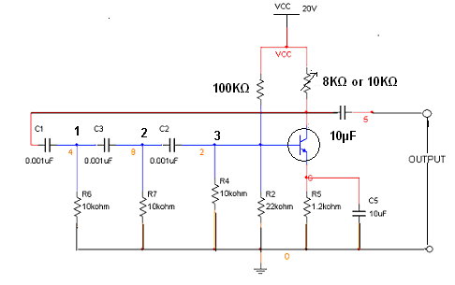

PROCEDURE:
- Make the connection as per the circuit diagram as shown above.
- Observe the output signal and note down the output amplitude and time period (T_{d}).
- Calculate the frequency of oscillations theoretically and verify it practically (f=1/T_{d}).
- Calculate the phase shift at each RC section by measuring the time shifts (T_{p}) between the final waveform and the waveform at that section by using the below formula.

OBSERVATIONS:

THEORITICAL CALCULATIONS: R = 10KΩ, C = 0.001 μf

1
f = -------------- =
2πRC* √6
PRACTICAL CALCULATIONS:

T_{d} =

1
f = -----
T_{d}

Tp₁
(1). θ ₁= --------*360⁰ =
T_{d}

Tp₂
(2). θ ₂ = ------- * 360⁰ ⁼
T_{d}

Tp₃
(3). θ ₃= ----------- *360⁰ =
T_{d}

MODEL WAVE FORMS:

OUT PUT WAVE FORM :
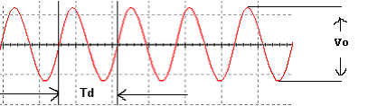

OUT PUT WAVE FORM : θ = 60⁰
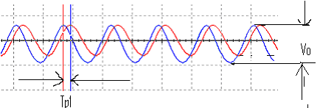
OUT PUT WAVE FORM : θ = 120⁰
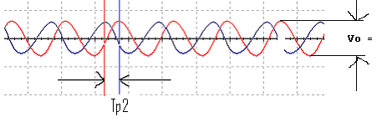

OUT PUT WAVE FORM : θ = 180

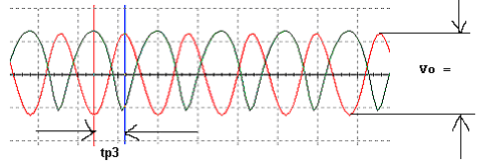
RESULT: The frequency of RC phase shift oscillator is calculated and the phase shift at different RC sections is noted.

VIVA QUESTIONS:

- What are the conditions of oscillations?
- Give the formula for frequency of oscillations?
- What is the total phase shift produce by the RC ladder network?
- Whether the oscillator is positive feedback or negative feedback?
- What are the types of oscillators?
- What is the gain of RC phase shift oscillator?
- What is the difference between damped oscillations undamped oscillations?
- What are the applications of RC oscillations?
- How many resistors and capacitors are used in RC phase shift network
- How the Barkhausen criterion is satisfied in RC phase shift oscillator

15. CURRENT-SERIES FEEDBACK AMPLIFIER
AIM: To measure the voltage gain of current - series feed back amplifier.
APPARATUS: Transistor BC 107
Breadboard
Regulated Power Supply (0-30V,1A)
Function Generator
CRO(30 Mhz,dualtrace)
Resistors 33kΩ,3.3kΩ,330Ω,1.5kΩ,2.2k Ω,4.7k Ω, 1 k Ω.
Capacitors 10µF - 2Nos
100µF

CIRCUIT DIAGRAM:
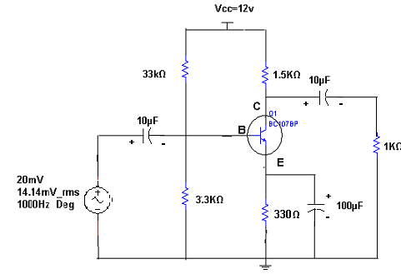
THEORY:
When any increase in the output signal results into the input in such a way as to cause the decrease in the output signal, the amplifier is said to have negative feedback.
The advantages of providing negative feedback are that the transfer gain of the amplifier with feedback can be stablised against varations in the hybrid parameteresof the transistor or the parameters of the other active devices used in the circuit. The most advantage of the negative feedback is that by propere use of this, there is significant improvement in the frequency respponse and in the linearity of the operation of the amplifier.This disadvantage of the negative feedback is that the voltage gain is decreased.
In Current-Series Feedback, the input impedance and the output impedance are increased.Noise and distortionsare reduced cosiderably.

PROCEDURE:
- Connections are made as per circuit diagram.
- Keep the input voltage constant at 20mV peak-peak and 1kHz frequency.For different values of load resistance, note down the output voltage and calculate the gain by using the expression
A_{v} = 20log(V₀ / V_{i} ) dB
- Remove the emitter bypass capacitor and repeat STEP 2.And observe the effect of feedback on the gain of the amplifier.
- For plotting the frquency the input voltage is kept constant at 20mV peak-peak and the frequency is varied from 100Hz to 1MHz.
- Note down the value of output voltage for each frequency. All the readings are tabulated and the voltage gain in dB is calculated by using expression A_{v} = 20log (V₀ / V_{i} ) dB
- A graph is drawn by takung frquency on X-axis and gain on Y-axis on semi log graph sheet
- The Bandwidth of the amplifier is calculated from the graph using the expression Bandwidth B.W = f₂ – f₁.
Where f₁ is lower cutt off frequency of CE amplifier
f ₂ is upper cutt off frequency of CE amplifier
- The gain-bandwidth product of the amplifier is calculated by using the expression
Gain-Bandwidth Product = 3-dB midband gain X Bandwidth.

OBSERVATIONS:
Voltage Gain: V_{i} = 20 mV

S.NO | Output Voltage (V_{o}) with feedback | Output Voltage (V_{o}) without feedback | Gain(dB) with feedback | Gain(dB) without feedback

Frquency Response:

S.NO | Frequency (Hz) | Output Voltage (V_{o}) | Gain A = V_{o}/V_{i} | Gain in dB  20log(V_{o}/V_{i})

MODEL WAVEFORM:
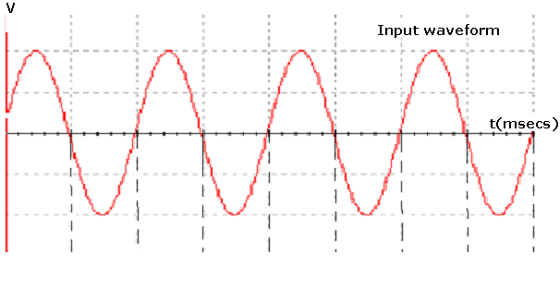

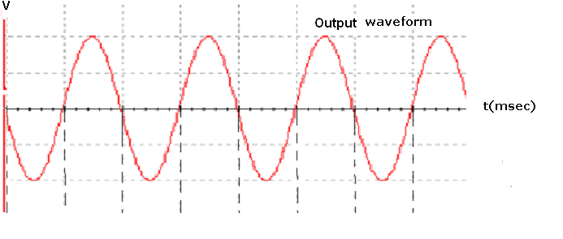

Frequency response

PRECAUTIONS:
- While taking the observations for the frequency response , the input voltage must be maintained constant at 20mV.
- The frequency should be slowly increased in steps.
- The three terminals of the transistor should be carefully identified.
- All the connections should be correct.
RESULT:
The effect of negative feedback (Current-Series Feedback ) on the amplifier is observed. The voltage gain and frquency response of the amplifier are obtained.Also gain-bandwidth product of the amplifier is calculated.

VIVA QUESTIONS
- What is the effect of Current-Series Feedback amplifier on the input inmpedance of the amplifier?
- What is the effect of negative feedback on the Bandwidth of an amplifier?
- State the reason for the usage of negative feedback in an amplifier?
- What are the fundamental assumptions that are made in studying feedback amplifiers?
- What are the advantages of providing negative feedback amplifier?
- What are the ideal characteristics of a voltage amplifier?\
- Draw the circuit for the current series feedback?
- What is the other name for current series feedback amplifier?
- What is the formula for input resistance of a current series feedback?
- What is the formula for output resistance of a current series feedback?

16. VOLTAGE-SERTES FEEDBACK AMPLIFIER
AIM: To study the effect of voltage series feedback on Gain of the Amplifier.
APPARATUS:
Transistor BC 107
Breadboard
Regulated Power Supply(0-30V,1A)
Function Generator
CRO(30 Mhz,dualtrace)
Resistors 33kΩ,3.3k Ω,1.5kΩ,1kΩ,2.2k Ω,4.7k Ω,330Ω
Capacitors 10µF - 2Nos
100µF - 1No

CIRCUIT DIAGRAM:
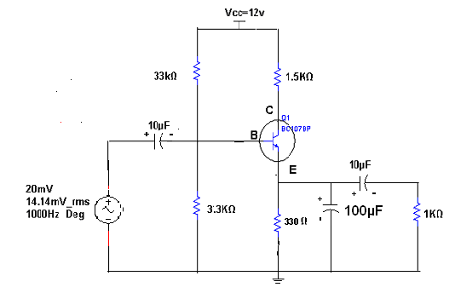

THEORY:
When any increase in the output signal results into the input in such a way as to cause the decrease in the output signal, the amplifier is said to have negative feedback.
The advantages of providing negative feedback are that the transfer gain of the amplifier with feedback can be stablised against varations in the hybrid parameteresof the transistor or the parameters of the other active devices used in the circuit. The most advantage of the negative feedback is that by propere use of this , there is significant improvement in the frequency respponse and in the linearity of the operation of the amplifier.This disadvantage of the negative feedback is that the voltage gain is decreased.
In Voltage-Series feedback , the input impedance of the amplifier is decreased and the output impedance is increased.Noise and distortionsare reduced cosiderably.

PROCEDURE:
- Connections are made as per circuit diagram.
- Keep the input voltage constant at 20mV peak-peak and 1kHz frequency.For different values of load resistance, note down the output voltage and calculate the gain by using the expression
A_{v} = 20log(V₀ / V_{i} ) dB
- Add the emitter bypass capacitor and repeat STEP 2.And observe the effect of Feedback on the gain of the amplifier
- For plotting the frquency the input voltage is kept constant at 20mV peak-peak and the frequency is varied from 100Hz to 1MHz.
- Note down the value of output voltage for each frequency. All the readings are tabulated and the voltage gain in dB is calculated by using expression A_{v} = 20log(V₀ / V_{i} ) dB
- A graph is drawn by takung frquency on X-axis and gain on Y-axis on semi log graph sheet
- The Bandwidth of the amplifier is calculated from the graph using the expression Bandwidth B.W = f₂ – f₁.
Where f₁ is lower cutt off frequency of CE amplifier
f ₂ is upper cutt off frequency of CE amplifier
The gain-bandwidth product of the amplifier is calculated by using the expression
Gain-Bandwidth Product = 3-dB midband gain X Bandwidth.

OBSERVATIONS:
Voltage Gain:

S.NO | Output Voltage (V_{o}) with feedback | Output Voltage (V_{o}) without feedback | Gain(dB) with feedback | Gain(dB) without feedback

Frquency Response: V_{i} = 20mV

S.NO | Frequency (Hz) | Output Voltage (V_{o}) | Gain A = V_{o}/V_{i} | Gain in dB  20log(V_{o}/V_{i})

MODEL WAVEFORMS:

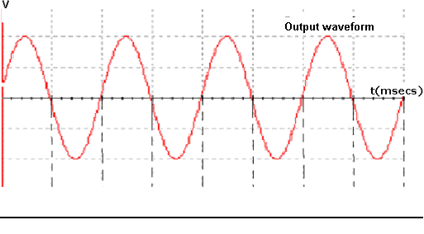

PRECAUTIONS :
- While taking the observations for the frequency response , the input voltage must be maintained constant at 20mV.
- The frequency should be slowly increased in steps.
- The three terminals of the transistor should be carefully identified.
- All the connections should be correct.

RESULT:
The effect of negative feedback (Voltage -Series Feedback ) on the amplifier is observed. The voltage gain and frquency response of the amplifier are obtained.Also gain-bandwidth product of the amplifier is calculated.

VIVA QUESTIONS
- What is meant by Feedback?
- What are the types of feedback amplifiers? Explain?
- Draw the circuit for voltage series feedback?
- What are the differences between positive and negative feedback?
- What is the effect of negative feedback on gain of an amplifier?
- What is the formula for voltage gain with negative feedback?
- What are the other names for positive and negative feedback circuits?
- What is the formula for input resistance of a voltage series feedback?
- What is the formula for output resistance of a voltage series feedback?

17. HARTLEY OSCILLATOR
AIM: To study and calculate frequency of oscillations of Hartley oscillator. Compare the frequency of oscillations, theoretically and practically.

APPARATUS: Transistor BC 107
Capacitors 0.1μF, 10 μF
Resistors 6.8Kohm, 1Kohm and 100Kohm
Decade inductance box (DIB)
Decade resistance box (DRB)
Cathode ray oscilloscope
Bread board
Regulated power supply (0-30V)
Connecting wires
CIRCUIT DIAGRAM:

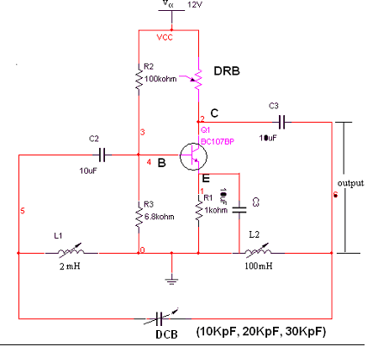

THEORY:
Hartley oscillator is very popular and is commonly used as a local oscillator in radio receivers. It has two main advantages viz... Adaptability to wide range of frequencies and easy to tune. The tank circuit is made up of L1, L2, and C1. The coil L1 is inductively coupled to coil L2, the combination functions as auto transformer. The resistances R2 and R3 provide the necessary biasing. The capacitance C2 blocks the d.c component. The frequency of oscillations is determined by the values of L1, L2 and C1 and is given by,

F=1/(2π(C1(√L1+L2)))

The energy supplied to the tank circuit is of correct phase. The auto transformer provides 180˚ out of phase. Also another 180˚ is produced
By the transistor. In this way, energy feedback to the tank circuit is in phase with the generated oscillations.

PROCEDURE:
1. Connections are made as per the circuit diagram.
2. Connect CRO at output terminals and observe wave form.
3. Calculate practically the frequency of oscillations by using the
Expression.
F=1/T, Where T= Time period of the waveform
4. Repeat the above steps 2, 3 for different values of L1 and note
Down practical values of oscillations of colpitts oscillator.
5. Compare the values of frequency of oscillations both theoretically
And Practically.

OBSERVATIONS:

CAPACITANCE(μF) | Theoritical frequency  (KHZ) | Practical frequency  (KHZ)

MODEL GRAPH:

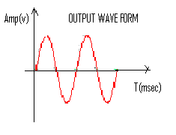

PRECAUTIONS:
- All the connections should be correct.
- Transistor terminals must be identified properly.
- Reading should be taken without any parallax error.

RESULT: Frequency of oscillations is calculated and compared with theoretical values.

VIVA QUESTIONS:

1. What are the applications of LC oscillations?
2. What type of feedback is used in oscillators?
3. What the expression for frequency of oscillations?
4. Whether an oscillator is dc to ac converter?
5. What is the loop gain of an oscillator?
6. What is the difference between amplifier and oscillator?
7. What is the condition for oscillations?
8. How many inductors and capacitors are used in Hartley Oscillator?
9. How the oscillations are produced in Hartley oscillator?
10. What is the difference between damped oscillations undamped oscillations?

18. COLPITT’S OSCILLATOR
AIM: To study and calculate frequency of oscillations of colpitt’s oscillator.
APPARATUS: Transistor BC 107
Capacitors 0.1µF - 2Nos
10µF - 2Nos
47µF - 1No
Resistors 6.8kΩ, 1kΩ,100kΩ
Decade Inductance Box (DIB)
Decade Resistance Box (DRB)
Cathode Ray Oscilloscope (CRO)
Regulated Power Supply (0-30V)
Connecting Wires
CIRCUITDIAGRAM:
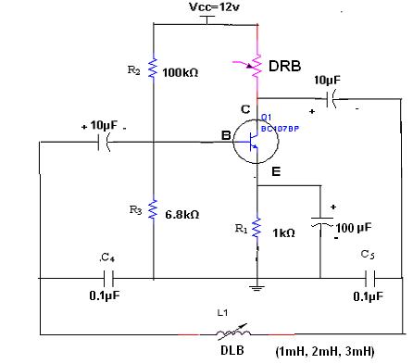
THEORY:
The tank circuit is made up of L₁,C₄ and C₅ .The resistance R₂ and R₃ provides the necessary biasing. The capacitance C₂ blocks the D.C component. The frequency of oscillations is determined by the values of L₁,C₄ and C₅, and is given by
f = 1 / (2π (C_{T}L1)^{1/2}) Where C_{T} = C₁C₂ / ( C₁ + C₂₎
The energy supplied to the tank circuit is of correct phase. The tank circuit provides 180⁰ out of phase. Also the transistor provides another 180⁰ . In this way, energy feedback to the tank circuit is in phase with the generated oscillations.
PROCEDURE:
- connections are made as per circuit diagram.
- Connect CRO output terminals and observe the waveform.
- Calculate practically the frequency of oscillations by using the expression
f = 1 / T ( T= Time period of the waveform)
- Repeat the above steps 2,3 for different values of L, and note down the practically values of oscillations of the collpitt’s oscillator.
- Compare the values of oscillations both theoritically and practically.

OBSERVATIONS:
Inductance ( mH ) | Theoretical Frequency  ( Hz ) | Practical Frequency  ( Hz )

MODELWAVEFORM:
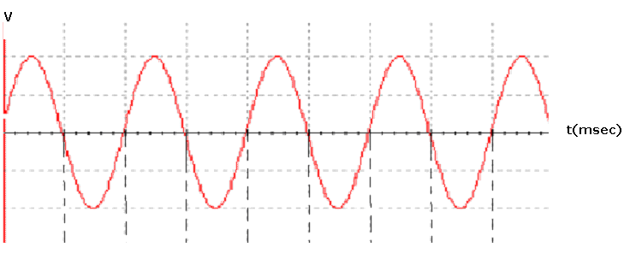
PRECAUTIONS:
- The connections should be correct.
- Transistor terminals should be identified properly.
- Readings should be taken without parallalox error.

RESULT: Frequency of oscillations of colpitts oscillator is measured practically and campared with theoritical values .
VIVA QUESTIONS:
- What are the applications of LC oscillators?
- What type of feedback is used in oscillators?
- What is the expression for the frequency of oscillations of colpitt’s oscillator?
- Is an oscillator DC to AC converter?
- What is the loop gain and loop phase shift of an oscillator?
- How does colpitt’s differ from Hartley?
- Which pair in circuit forms stabilizing circuit?
- What is the function of input and output capacitor?
- What is the condition for sustained oscillations in this oscillator?
- Output capacitor acts as a?

19. SILICON-CONTROLLED RECTIFIER(SCR) CHARACTERISTICS
AIM: To draw the V-I Charateristics of SCR
APPARATUS: SCR (TYN616)
Regulated Power Supply (0-30V)
Resistors 10kΩ, 1kΩ
Ammeter (0-50) µA
Voltmeter (0-10V)
Breadboard
Connecting Wires.

CIRCUIT DIAGRAM:

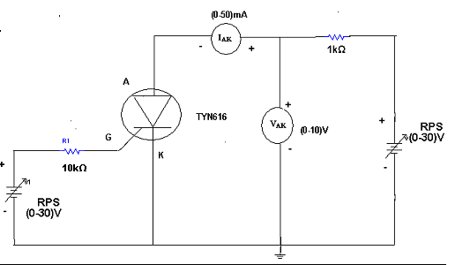

THEORY:
It is a four layer semiconductor device being alternate of P-type and N-type silicon. It consists os 3 junctions J₁, J₂, J₃ the J₁ and J₃ operate in forward direction and J₂ operates in reverse direction and three terminals called anode A, cathode K , and a gate G. The operation of SCR can be studied when the gate is open and when the gate is positive with respect to cathode.
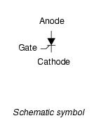
When gate is open, no voltage is applied at the gate due to reverse bias of the junction J₂ no current flows through R₂ and hence SCR is at cutt off. When anode voltage is increased J₂ tends to breakdown.
When the gate positive,with respect to cathode J₃ junction is forward biased and J₂ is reverse biased .Electrons from N-type material move across junction J₃ towards gate while holes from P-type material moves across junction J₃ towards cathode. So gate current starts flowing ,anode current increaase is in extremely small current junction J₂ break down and SCR conducts heavily.
When gate is open thee breakover voltage is determined on the minimum forward voltage at which SCR conducts heavily.Now most of the supply voltage appears across the load resistance.The holfing current is the maximum anode current gate being open , when break over occurs.
PROCEDURE:
- Connections are made as per circuit diagram.
- Keep the gate supply voltage at some constant value
- Vary the anode to cathode supply voltage and note down the readings of voltmeter and ammeter.Keep the gate voltage at standard value.
- A graph is drawn between V_{AK} and I_{AK} .
OBSERVATION
V_{AK}(V) | I_{AK} ( µA)

MODEL WAVEFORM:
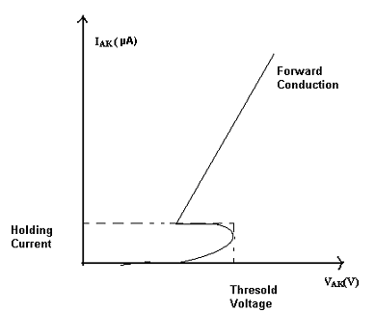
RESULT: SCR Characteristics are observed.
VIVA QUESTIONS
- What the symbol of SCR?
- IN which state SCR turns of conducting state to blocking state?
- What are the applications of SCR?
- What is holding current?
- What are the important type’s thyristors?
- How many numbers of junctions are involved in SCR?
- What is the function of gate in SCR?
- When gate is open, what happens when anode voltage is increased?
- What is the value of forward resistance offered by SCR?
- What is the condition for making from conducting state to non conducting state?

20. UJT CHARACTERISTICS

AIM: To observe the characteristics of UJT and to calculate the Intrinsic Stand-Off Ratio (η).

APPARATUS:
Regulated Power Supply (0-30V, 1A) - 2Nos
UJT 2N2646
Resistors 10kΩ, 47Ω, 330Ω
Multimeters - 2Nos
Breadboard
Connecting Wires

CIRCUIT DIAGRAM

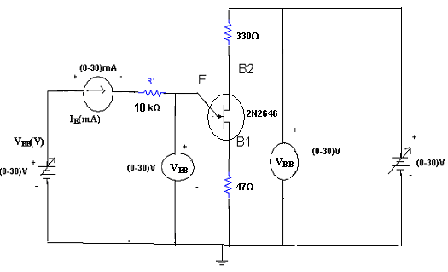

THEORY:
A Unijunction Transistor (UJT) is an electronic semiconductor device that has only one junction. The UJT Unijunction Transistor (UJT) has three terminals an emitter (E) and two bases (B1 and B2). The base is formed by lightly doped n-type bar of silicon. Two ohmic contacts B1 and B2 are attached at its ends. The emitter is of p-type and it is heavily doped. The resistance between B1 and B2, when the emitter is open-circuit is called interbase resistance.The original unijunction transistor, or UJT, is a simple device that is essentially a bar of N type semiconductor material into which P type material has been diffused somewhere along its length. The 2N2646 is the most commonly used version of the UJT.
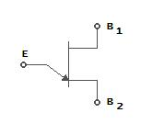

Circuit symbol
The UJT is biased with a positive voltage between the two bases. This causes a potential drop along the length of the device. When the emitter voltage is driven approximately one diode voltage above the voltage at the point where the P diffusion (emitter) is, current will begin to flow from the emitter into the base region. Because the base region is very lightly doped, the additional current (actually charges in the base region) causes (conductivity modulation) which reduces the resistance of the portion of the base between the emitter junction and the B2 terminal. This reduction in resistance means that the emitter junction is more forward biased, and so even more current is injected. Overall, the effect is a negative resistance at the emitter terminal. This is what makes the UJT useful, especially in simple oscillator circuits.When the emitter voltage reaches V_{p}, the current startsto increase and the emitter voltage starts to decrease.This is represented by negative slope of the characteristics which is reffered to as the negative resistance region,beyond the valleypoint ,R_{B1} reaches minimum value and this region,V_{EB} propotional to I_{E.}
PROCEDURE:
- Connection is made as per circuit diagram.
- Output voltage is fixed at a constant level and by varying input voltage corresponding emitter current values are noted down.
- This procedure is repeated for different values of output voltages.
- All the readings are tabulated and Intrinsic Stand-Off ratio is calculated using η = (V_{p}-V_{D}) / V_{BB}
- A graph is plotted between V_{EE} and I_{E} for different values of V_{BE.}
MODEL GRAPH:
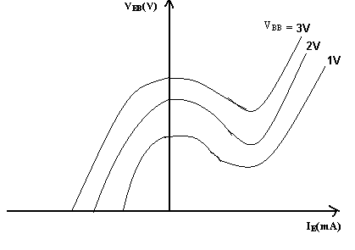
OBSEVATIONS:
V_{BB}=1V |  | V_{BB}=2V |  | V_{BB}=3V
V_{EB}(V) | I_{E}(mA) | V_{EB}(V) | I_{E}(mA) | V_{EB}(V) | I_{E}(mA)
CALCULATIONS:
V_{P} = ηV_{BB} + V_{D}
η = (V_{P}-V_{D}) / V_{BB}
η = ( η₁ + η₂ + η₃ ) / 3
RESULT: The characteristics of UJT are observed and the values of Intrinsic Stand-Off Ratio is calculated.
VIVA QUESTIONS

- Wha is the symbol of UJT?
- Draw the equivalent circuit of UJT?
- What are the applications of UJT?
- Formula for the intrinsic stand off ratio?
- What does it indicates the direction of arrow in the UJT?
- What is the difference between FET and UJT?
- Is UJT is used an oscillator? Why?
- What is the Resistance between B₁ and B₂ is called as?
- What is its value of resistance between B₁ and B_{2?}
- Draw the characteristics of UJT?

21. BRIDGE RECTIFER

AIM: - To calculate the ripple factor of a bridge rectifier, with and without filters.

APPARATUS:-
Experimental board
Diodes, IN4007 ---- 4 Nos.
Resistor, 1KΩ
Capacitor, 100μF/25v.
Transformer (6-0-6v)
Multi meters –2 No
Connecting Wires

CIRCUIT DIAGRAM:-
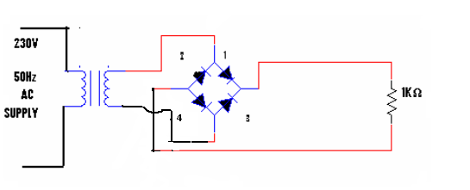
THEORY:-
The bridge rectifier is also a full-wave rectifier in which four p-n diodes are connected in the form of a bridge fashion. The Bridge rectifier has high efficiency when compared to half-wave rectifier. During every half cycle of the input, only two diodes will be conducting while other two diodes are in reverse bias.

PROCEDURE:-
1. Connections are made as per the circuit diagram.
2. Connect the ac main to the primary side of the transformer and secondary side to the bridge rectifier.
3. Measure the ac voltage at the input of the rectifier using the multi meter.
4. Measure both the ac and dc voltages at the output of the Bridge rectifier.
5. Find the theoretical value of dc voltage by using the formula,

CALCULATIONS:-
Theoretical calculations:-
Vrms = Vm/ √2
Vm =Vrms√2
Vdc=2Vm/П
(i)Without filter:
Ripple factor, r = √ ( Vrms/ Vdc )² -1 = 0.482
(ii)With filter:

Ripple factor, r = 1/ (4√3 f C R_{L}) where f =50Hz
C =100µF
R_{L}=1KΩ
Practical Calculations:-
Without filter:-
Vac=
Vdc=
Ripple factor, r=Vac/Vdc
With filters:-
Vac=
Vdc=
Ripple factor,r=Vac/Vdc
OBSEVATIONS:-
Without Filter

USING DMM | V_{ac}(v) | V_{dc}(v) | r= V_{ac}/ V_{dc}

With Filter

USING DMM | V_{ac}(v) | V_{dc}(v) | r= V_{ac}/ V_{dc}

Without Filter:-
Vrms = Vm/ √2 , Vdc=2Vm/П , Vac=√( Vrms²- Vdc ²)

USING CRO | V_{m}(v) | V_{ac}(v) | V_{dc}(v) | r= V_{ac}/ V_{dc}

WITHFILTER
USINGCRO | V₁(V) | V₂(V) | V_{dc}= (V₁+V₂)/2 | V_{ac}=  (V₁₋ V₂)/2√3 | r=  V_{ac}/ V_{dc}

MODELWAVEFORM:-

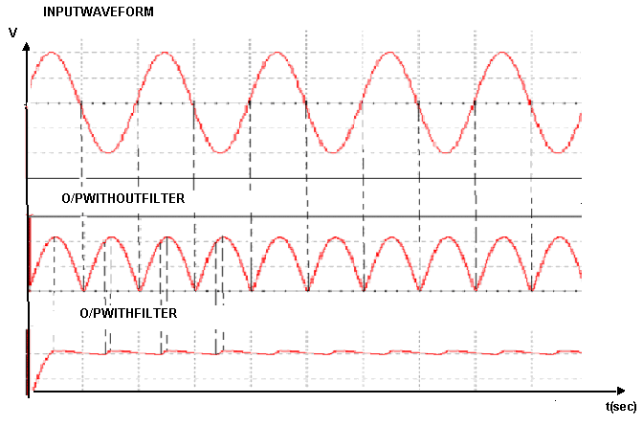

PRECAUTIONS:-

1. The voltage applied should not exceed in the ratings of the diode
2. The diodes will be connected correctly

RESULT:-

The Ripple factor of Bridge rectifier is with and without filter calculated.

VIVAQUESTIONS:-

1. What is the PIV of Bridge rectifier?
2. What is the efficiency of Bridge rectifier?
3. What are the advantages of Bridge rectifier?
4. What is the difference between the Bridge rectifier and fullwaverectifier?
5. What is the o/p frequency of Bridge Rectifier?
6. What is the disadvantage of Bridge Rectifier?
7. What is the maximum secondary voltage of a transformer?
8. What are the different types of the filters?
9. What is the difference between the Bridge rectifier and half wave
Rectifier?
10. What is the maximum DC power delivered to the load?

REDDY4UUU@yahoo.com

